 |  |  | Shakespeare Timeline
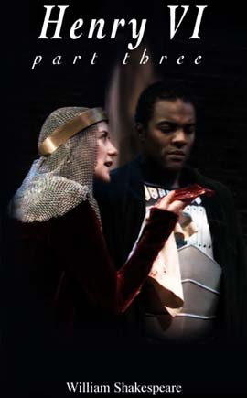
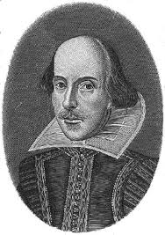
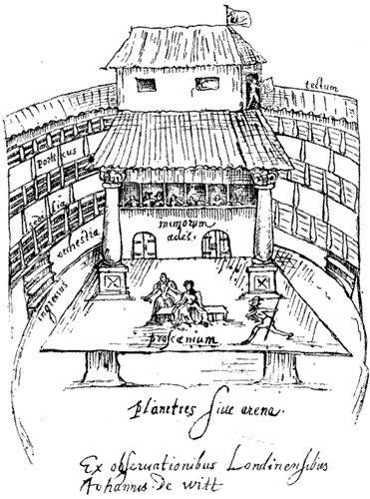
William Shakespeare was born to Mary and John
John Shakespeare takes William to a play in the town they lived in
William Shakespeare married Anne Hathaway
William Shakespeare leaves his wife and children at home in Stratford and travels to London to work as an actor and playwright
William Died
Shakespeare first play was produced "Henry VI, part 1"
William and a group of other actors build The Globe, a new theatre.
Globe burnt down

 |  |  | 1560 | 1570 | 1580 | 1590 | 1600 | 1610 | 1620

